SiO₂/4H-SiC interface: the key of the MOSFET V_{th} instability

Patrick Fiorenza
CNR-IMM, Catania

Silicon carbide (4H-SiC) is an excellent wide band gap semiconductor for the fabrication of metal oxide semiconductor field effect transistors (MOSFETs) suitable for highly efficient power switching applications. However, the device behavior is strongly influenced by SiO₂/4H-SiC interface properties and some issues still limit the 4H-SiC MOSFET performances, e.g. the threshold voltage (V_{th}) instability phenomena and the poor channel mobility. To get more insights on these physical aspects, the methods commonly adopted for the SiO₂/Si system are not valid in SiC, due to the different intrinsic nature of the SiO₂/4H-SiC interface.
In this presentation, advanced electrical characterization methods developed at CNR-IMM to identify the different trapping mechanisms at the SiO₂/4H-SiC interface and in the near interface oxide region will be presented [1]. In particular, it will be shown that the develop approach allowed clarifying the impact of the interface chemistry on the electrical behaviour of devices fabricated under different process conditions [2].
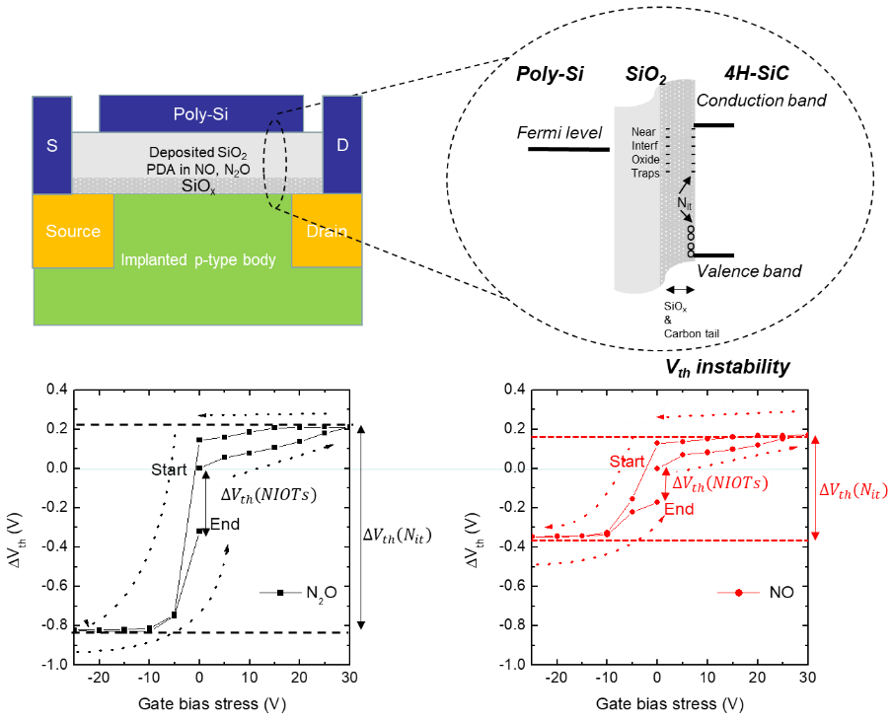
[1] P. Fiorenza, F. Giannazzo, S. Cascino, M. Saggio, F. Roccaforte; Appl. Phys Lett. 117, 103502 (2020)
[2] P. Fiorenza, C. Bongiorno, F. Giannazzo, M. S. Alessandrino, A. Messina, M. Saggio, F. Roccaforte; Appl. Surf. Sci. 557, 149752 (2021)

