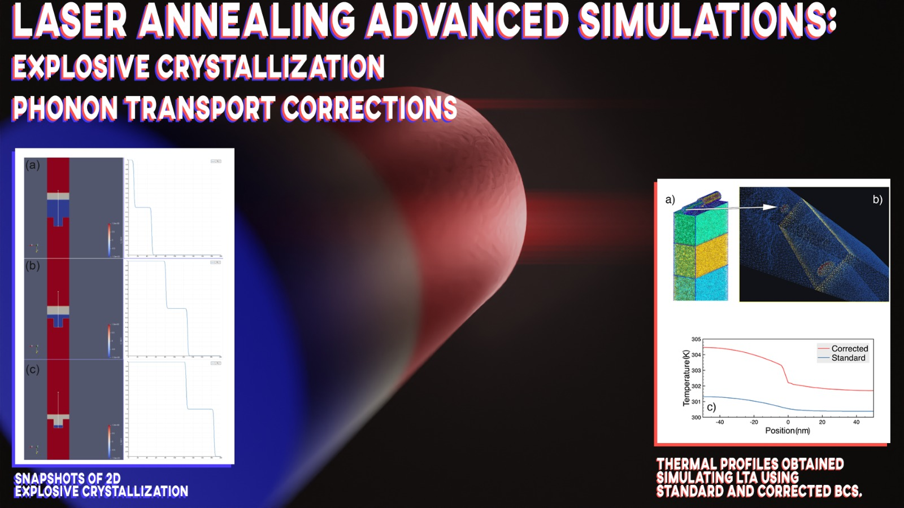

Laser thermal annealing (LA) is integrated, as micro- and nano- electronics processing step, when strongly confined heating is needed in the semiconductor device manufacturing flows.
One of the main challenges for the application of the process in future devices is to achieve an optimal process control. That is why a reliable simulation of the process is needed, and despite models of LA have been implemented in academic or commercial packages, a further evolution of the methods is necessary for the general application in complex structures with nm wide elements where the thermal transport could be dominated by phonon effects. Moreover, ultra-fast (explosive) phase transitions occur during the irradiation of device elements and their modelling is a challenging objective for the LA simulators’ development. In this context we integrate phonon transport corrections and modeling of explosive crystallization to our existing simulation tool, LIAB (LASSE Innovation Application Booster) that will help us to reproduce experimental data and predict behavior of semiconductor structures upon laser annealing.
About the phonon corrections we simulated thermal transport induced by conventional and laser annealing in various structures comparing the results in which standard conditions and corrections were applied, noticing that there is a size dependent discrepancy between standard and corrected solutions. Regarding explosive crystallization we successfully simulated this challenging behavior including secondary melting during the process. The code we developed uses the FEniCS computing platform for solving continuum fields evolution and Gmsh as 3D finite element mesh generator.

