Advanced characterization from the nanoscale to the single atom with a glance to the next in-situ performances
Dr. Giuseppe Nicotra
10th September 2021
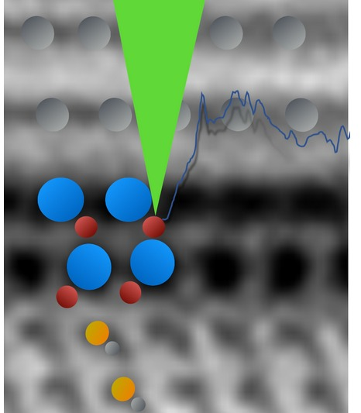

Scanning Transmission Electron microscopy is one of the most powerful characterization tool able to explore the 2D limits in semiconductors design.
Thanks to the sub-Å resolution combined with the incoherent contrast, the simple intuitive nature of the materials may be directly imaged and easily understood.
IMM-Headquarter owns one of the most powerful tool ever installed. Performance and results will be presented.

